Topic: Trade in the Ancient Indian Ocean: Magan and the Early Monsoon Trade

Author: Tasnim Albusaidi

Age Group: Middle School

Introduction:
In ancient Middle East, two regions dominated the eco-political landscape; the civilizations of Mesopotamia and the Nile River Delta. Mesopotamia, known as the "fertile crescent," was an area important for food production and connecting east to west trade. Ancient civilizations like the Sumerians and the Babylonians utilized the natural resources of Mesopotamia to fuel their empires. Mesopotamia became an important place of ancient international trade. However, the land of Mesopotamia did not provide everything these ancient civilizations required. Even though the soil between the Tigris and the Euphrates Rivers produced a large surplus of food, it did not support large forests so timber was scarce. The area also lacked mineral resources needed for metallurgy, especially the copper deposits critical to the smelting of bronze. The copper and timber that fueled Mesopotamia’s Bronze Age advancement came from Magan. Magan was located in modern day Oman. It was an ancient region referred to in Sumerian Cuneiform texts dated to 2300 BCE. Magan was an important trading stop on the way from Mesopotamia to the Indus valley.

In this lesson, students will be able to understand the role Magan played in ancient international trade. This lesson will illustrate that regional and globalized trade is not a purely modern phenomenon. From 2800-1800 BCE, Magan was a prosperous region that connected with and was important to the other major civilizations of the ancient near east and Indus Valley.

Lesson Design:

Part I:
Background:
In this lesson, students will begin by watching a YouTube video that introduces the history of Indian Ocean trade. The video explains the importance of the monsoon winds to Indian Ocean trade, types of goods traded, and the role of technology in these trade networks: (Link: https://www.youtube.com/watch?v=a6XtBLDmPA0) (10 minutes).

Next, students will read “The Land of Magan” (http://ancientoman.cfs.unipi.it/fileadmin/user_upload/Land_of_Magan.pdf ) article to further understand Magan’s history. After reading the article, students need to complete the article worksheet. The teacher will lead the class discussion where students will participate and answer the questions about Magan (about 45 minutes).

Materials:
- Computer lab to access Indian Ocean in World History
- World Map (Ancient Era, access from Indian Ocean in World History website)
- Markers
- Notebook paper
- Writing utensils

Time Necessary: Two class periods

Part II:
- Activity for lesson:
- Part One: After reading and discussing with the class, students are to get into groups of 3-4, go to the computer lab, and access the Indian Ocean World History website. There, click on “Maps” click on “Ancient Era”.
Part Two: Each group needs to pick an icon, and begin to research. Their goal is to discover the importance of the icon. There is an attached worksheet “Trade in the Ancient Indian Ocean: Magan and the Early Monsoon Trade Research” for further instructions.
-Part Three: After researching, students are to create a presentation to share with the class the following day. The rubric of the presentation is attached “Group Presentation Rubric”.

Part III:
- At the end of this lesson, students should be able to understand the role Magan played in ancient international trade. Because of Magan, people were able to access goods such as copper, stone diorite, and timber, which were important for building, producing utensils, weapons, and art. As the students read the article about Magan, and research its important goods, they will be able to understand how important Magan’s goods were during the Ancient Era.

The Land of Magan Questions
- List the raw materials that were found in Magan:

- What did Magan trade with Mesopotamia? What did it receive in return? What does this trade pattern tell you about both civilizations?

- What kind of supplies did copper help manufacture?

- Why were ships important during the Ancient Era?

- What were Magan boats built with? Why is this important? Where did these materials come from?

Trade in the Ancient Indian Ocean: Magan and the Early Monsoon Trade Research
Introduction:
Step by step instructions:
- Students are to work in groups of 3-4
- For this research, please visit the Indian Ocean Indian Ocean in World History website, http://indianoceanhistory.org/default.aspx
- click on “Maps”
- Click on “Ancient Era”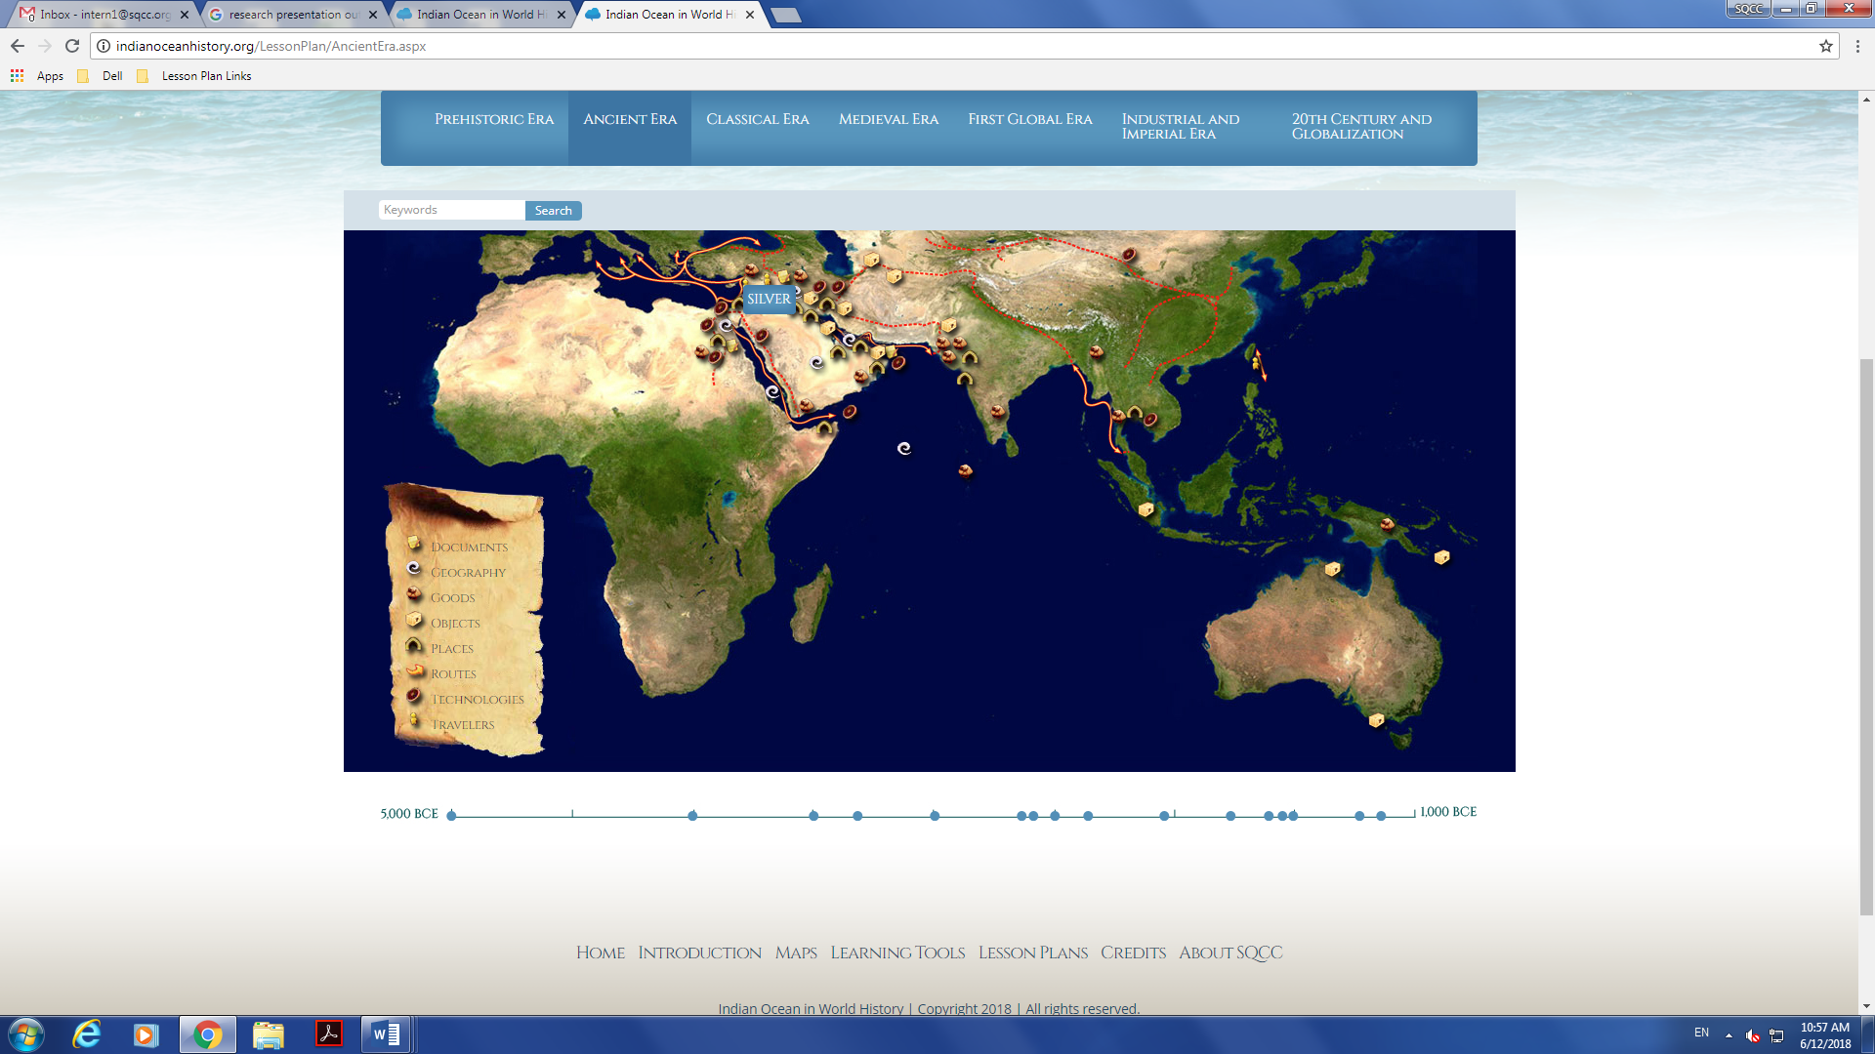

- On the left side, the groups is to choose one icon
- Icons to choose from include:
    - Icons closely related to Magan:
      - Copper was a rich resource in Magan and helped make tools, weapons, utensils, sculptures, and jewelry.
      - Magan, located in what today is as Oman, Magan is the ancient name for a region linked by trade with Mesopotamia and the Indus valley.
      - Magan boat, used for trading in the Arabian Gulf and beyond.
      - Earliest Record Naval Battle took place in Magan around 2200 BC.
    - Other icons not closely related, but were beneficial:
      - Combs, Ubaid pottery, Silver, board games, grain were goods brought into Magan during the Ancient civilization.
      - Tigris and Euphrates Rivers helped farmers farm and create communities. They also people became dependent of these rivers as they were important for trading during the time as it carried ships into the Arabian (Persian) Gulf.
      - Pottery was common in the ancient world. Pots from Mesopotamian and the Indus valley were found in Oman (Magan) as well as other locations on the Arabian Peninsula.
- Students are to click on the icons they chose (Specifically focus on the icons surrounding the above picture, read about them, and identify their importance for Magan as well as how they were used during the time period.
On the presentations, students must identify the following:
  - Icon
  - Where was it discovered
  - When was it discovered
  - How was it used
  - Who discovered it (if found)
- Students are allowed to use visuals such as pictures and videos.
- Every presentation must be 5-7 minutes.
- The type of presentation is flexible. Students can choose to make a PowerPoint, Prezi, poster, or any other type of presentation if approved by the teacher.

Name: ______________________
Group Number: _______________
Date: _______________________
Group Presentation Rubric: Title: _______________________________________________
Group Members: 1. _____________ 2. ________________ 3. _________________ 4._______________________

Category | 4 | 3 | 2 | 1
preparation | Student is completely prepared and has rehearsed | Student seems pretty prepared, but might have needed more time to rehearse | The student is somewhat prepared, but it is clear that he/she did not rehearse | Student does not seem at all prepared to present
Comprehension | Student is able to explain the topic to their classmates | Student is able to somewhat explain the topic to their classmates | The student is lacking in explaining the topic to their classmates | Student read the slides, and I cannot tell if they understood the topic
Volume and Presentation Skills | Student speaks clearly and loud enough to be heard by all audience members throughout the presentation. Did not read everything from the presentation | Student is loud enough to be heard by almost all of the audience members, and did not read everything from the presentation | Student is loud enough to be heard by half of the audience members, and did not read everything from the presentation | Student is speaking soft, not heard by the audience members, and read directly from the presentation
Stays on Topic and Appears Organized | Stays on topic the whole time and presentation is well organized | Stays on topic most of the time, and presentation is clearly organized | Stays on topic most of the time, and presentation is somewhat organized | It was hard to tell what the topic was, and the presentation was unclear
Peer Grading | Received mostly 4’s from other group members. | Received mostly 3’s from other group members | Received mostly 2’s from other group members | Received mostly 1’s from other group members

Notes: TOTAL SCORE: _________

